Duncan Memorial United Methodist Church
A 180 Year
Congregational History
1838 through 2018

From a small meeting house in 1838
To a larger frame building in 1871
To a ‘permanent’ brick Church in 1884
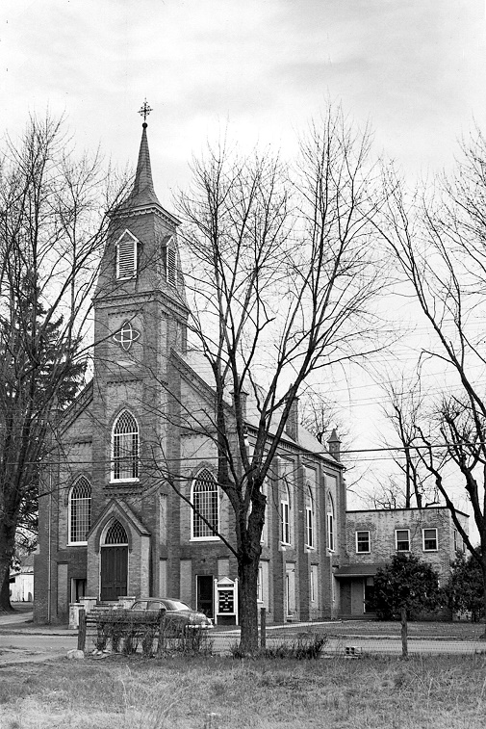
To our current Church in 2018
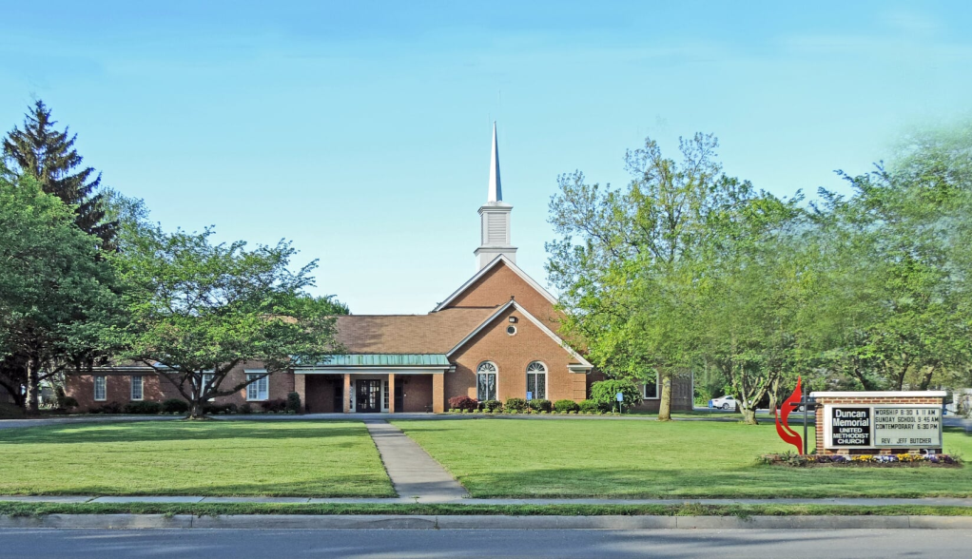

Compiled by John W. Mallery for our 180th Celebration
Duncan Memorial
United Methodist Church
A Fellowship That Has Worshipped Together Since 1838
Its History 1838 to 2018

On January 15, 1798 the small Virginia town then known as Battletown was purchased by Benjamin Berry and Sarah (Berry) Stribling and established as a town named Berryville. By 1810, the new town had at least 25 homes, three stores, an apothecary, two taverns and an academy. It had grown much larger by the time it was designated as the county seat when Clarke County was formed in 1836. In 1855 it was described as “a small town with an academy and one or two churches.”
During this time, the Methodist Episcopal Church had established a Conference in Baltimore, Maryland, directing Methodist Circuit Riders to serve charges such as the one appointed at White Post. Circuit Riders such as Frank A. Strother and William H. Hedges served two nearby Methodist gatherings, one which became known as “Cain’s Chapel” located on old Senseny Road near the present Humston Farm. Land for this Chapel was donated by Peter Cain when he deeded it in 1847 as land for worship of God by the “Methodist Church in the United States of America”.
A second meeting place was established in 1838 at the nearby town of Berryville where those meeting also decided to buy property for a church. This was accomplished with the purchase of a half-acre lot with a small building on the north side of East Main Street from John W. Owens and wife for $200.00 as recorded in a deed filed by Levi Cain a Church Trustee in 1840. Over the next years, the Methodist Church struggled with the issue of slavery as did the rest of the American States. As early as 1808, the General Conference surrendered by creating the Methodist Episcopal Church North and the Methodist Episcopal Church South. We became known as the Berryville, M.E. Church South. Circuit Rider Rev. William Hedges joined the Baltimore Conference South in 1859 and was first assigned to the Berryville area. During the War Between the States, Rev. Hedges served the Southern forces preaching to all in need within his charge. Between 1864 and 1867, Rev. Hedges was assigned to serve as an assistant pastor of the Berryville M.E. Church South.
After the Civil War ended, the Baltimore Conference North tried to take possession of the southern churches. A Rev. Mr. Lanahan was sent to our circuit to take possession of our Berryville M.E. Church South. The character and loyalty of our Rev. Hedges was demonstrated in a confrontation that took place one Sunday night. Reverend Hedges was determined not to let our church be taken by the northerners. The following is an account of his stand.
“Whenever Rev. Hedges would start to preach, Rev. Lanahan would start to preach. Whenever Rev. Lanahan would start to preach, the choir would sing. This singular contest was kept up for several hours. Both preachers determined to carry their point. Mr. Lanahan getting in a sentence at a time. The choir almost exhausted itself singing him down whenever he arose. After a while a number of young men in the community made their way gradually through the vast crowd until they reached the pulpit, a note was handed Mr. Lanahan telling him that this affair had to stop and giving him ten minutes to which he could leave town. He immediately called out for a Magistrate. Mr. Mathew Pulliam, who was present, said that he was one and would promise that the Reverend would get out of town safely. The Reverend Lanahan decided to leave. He did so in safety, but badly frightened, The matter was later worked out in the Courts and the people of the Berryville M.E. Church South kept their Church.”
As Berryville grew during and after the Civil War, a new frame building was built in 1871 to accommodate the growing congregation. This new Church was built with the help of Peter Cain and some of the leading members from Cain’s Chapel. About this same time the Baltimore Conference North attempted to start a “Northern Methodist Church” in Berryville by building a frame church on land now owned and occupied by Mr. E.N. Barnett. This church project survived a few years until it was suspended and subsequently torn down. As the town grew over the next ten years, the need for a new ‘permanent’ Church was developed. One of the last of the Circuit Riders, Rev. Frank A. Strother was assigned to our Church at the time and helped create the new two story brick building to be constructed between 1882 and 1884 replacing the outgrown 1871 meeting house.

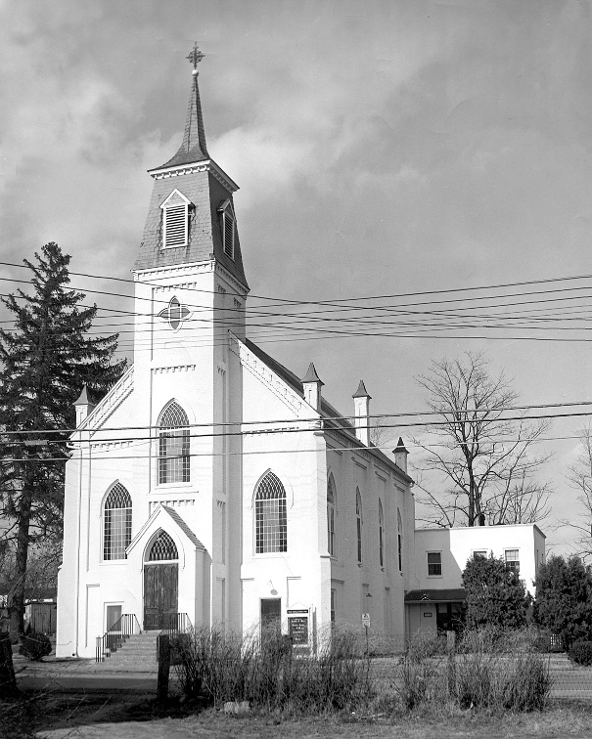
The building had to be of brick with a basement and a slate roof. The sanctuary was 35 feet by 55 feet. It was heated by two hot air stoves which sat on the first floor with two registers above in each of the two aisles. One of our older parishioners states that sometimes they nearly froze in church. The church was lighted with lamps and reflectors that cost $55.55 each and swung from the ceiling. They were fortunate to buy 16 (second hand) windows with green and white panels as commonly seen during those days from a party in Pennsylvania for $160.00. (Four needed a little repair which was done in Phillip’s repair shop.) A “hand-pump” organ was purchased for $336.00 a few years later. Boys would bid for their turn in pumping the organ. Melton Bean was one of those boys. He says he went to sleep one Sunday and had to be awakened for the closing hymn.
As can be seen in the following photograph, the sanctuary was physically divided down the middle with the men designated to sit on the left and the ladies on the right. This older tradition didn’t survive very long as the families tended to sit together as did the younger adults.
As the church grew its congregation, it filled every bit of its space with classes. Both Mr. Affleck and Mr. George J. Cunningham who succeeded him as Sunday School Superintendents, inspired people to join the numerous Sunday Schools. The primary and beginners classes were grouped together in what was called the ”Infant Class” on the first floor in the small room to the left of the entrance. The Men’s Bible Class Room was a hallway leading into the main room with a little winding stairway leading upstairs. Other classes met in the main room downstairs and in the upstairs sanctuary. Many pictures are in our archives, a few of which are shown here to provide an insight into Sunday School Classes, activities and a view of the interior of the old Church.
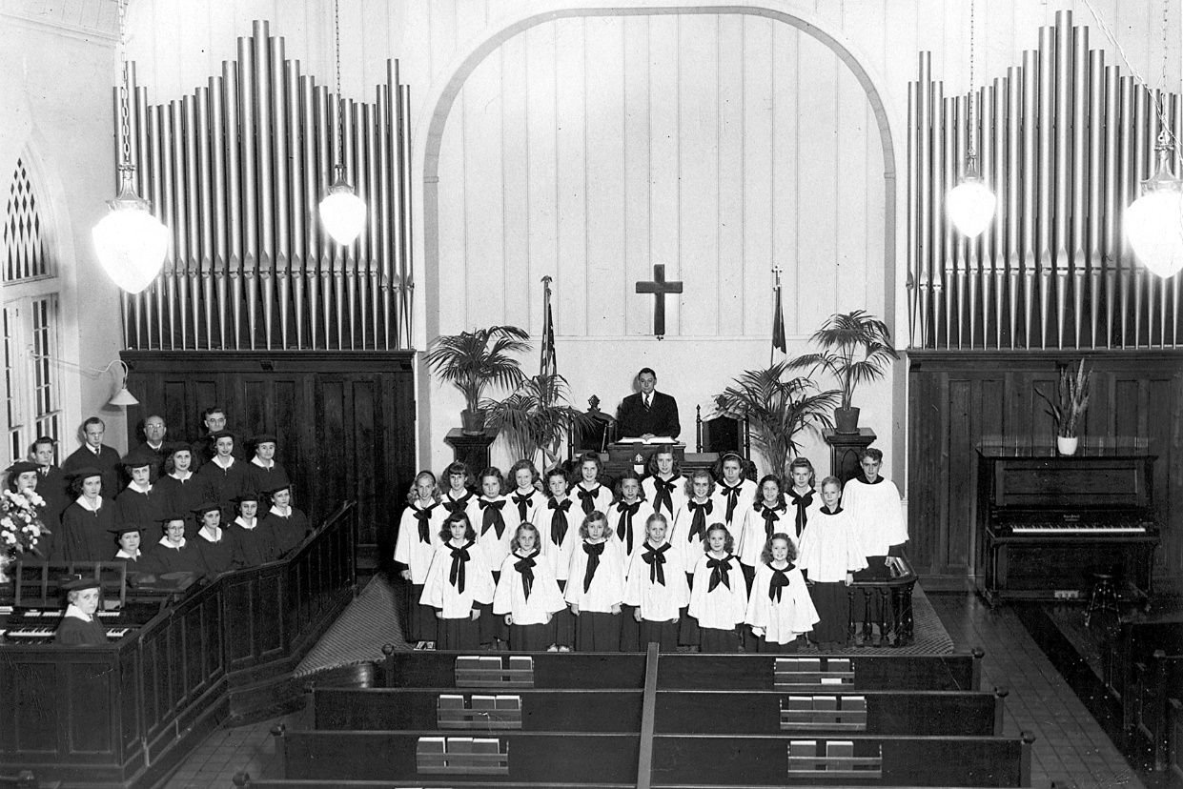
Choirs with Reverend Lightner Later Years with Electrification and Moller Organ

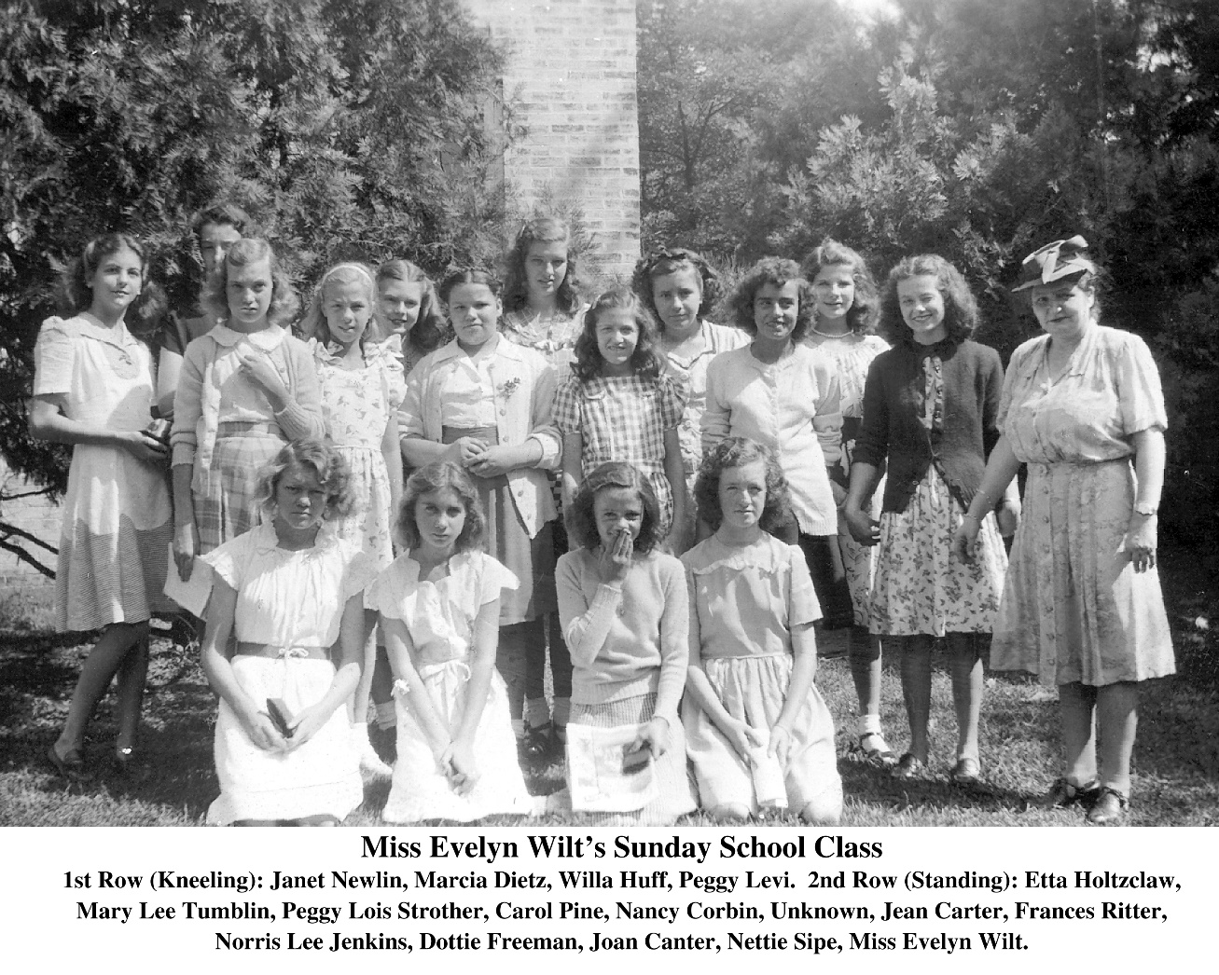
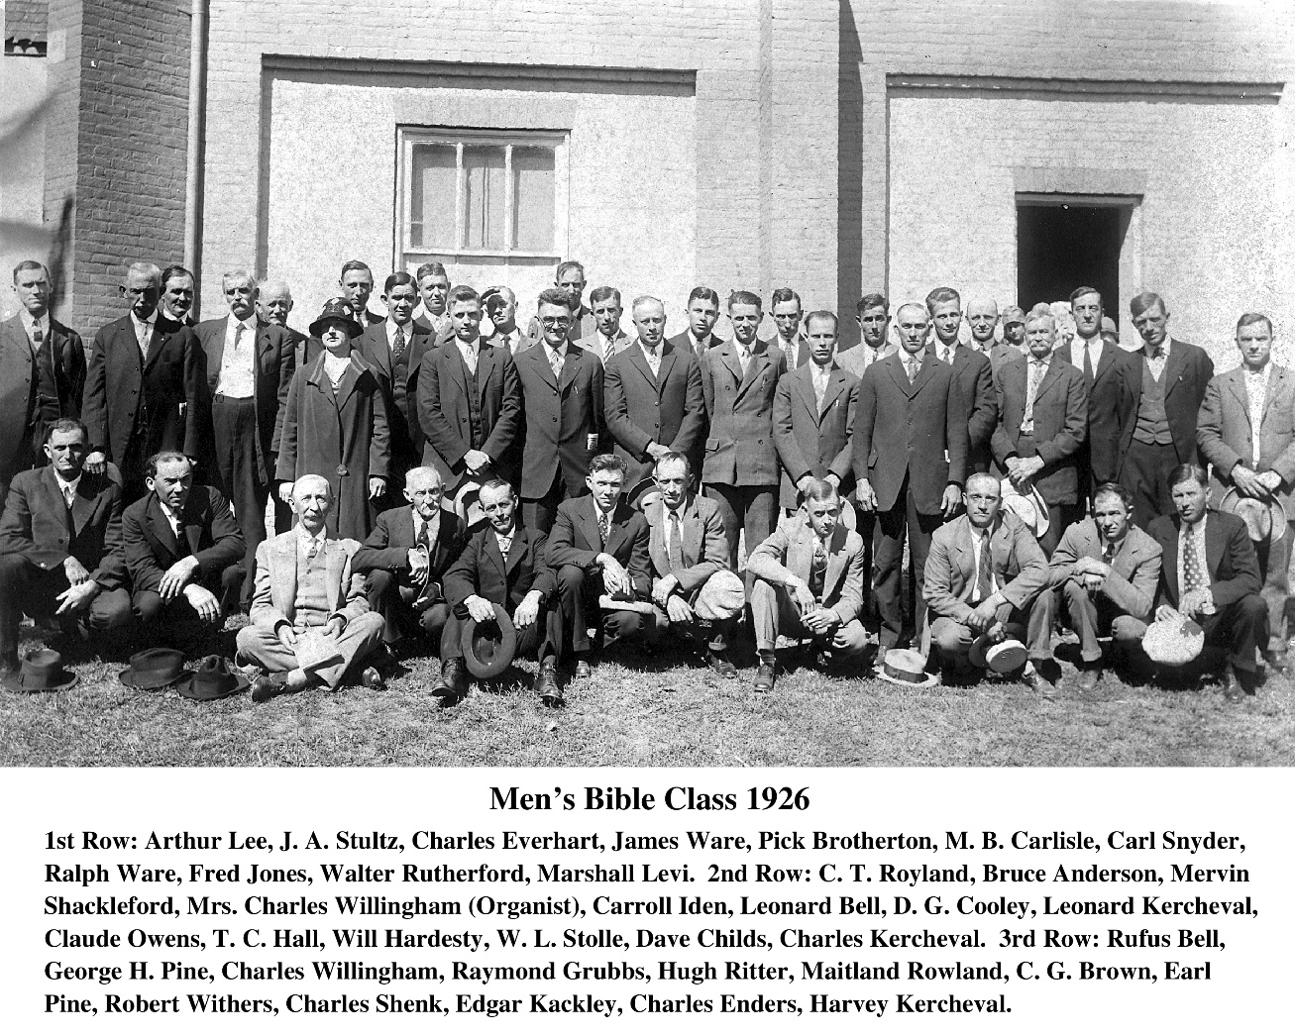

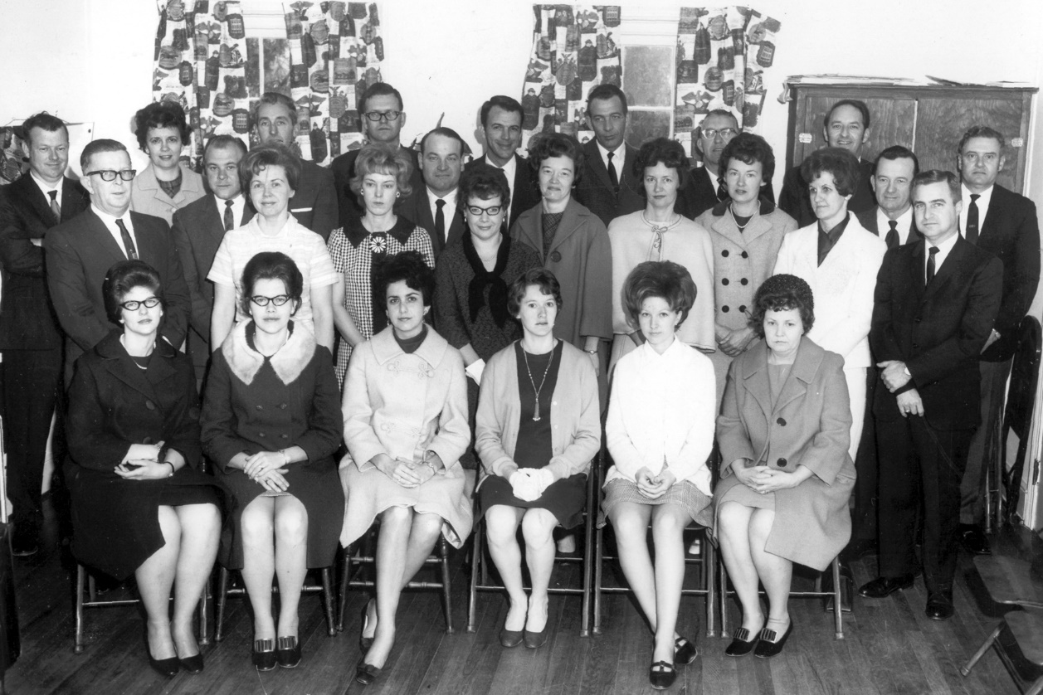
Pilgrims Bible Class

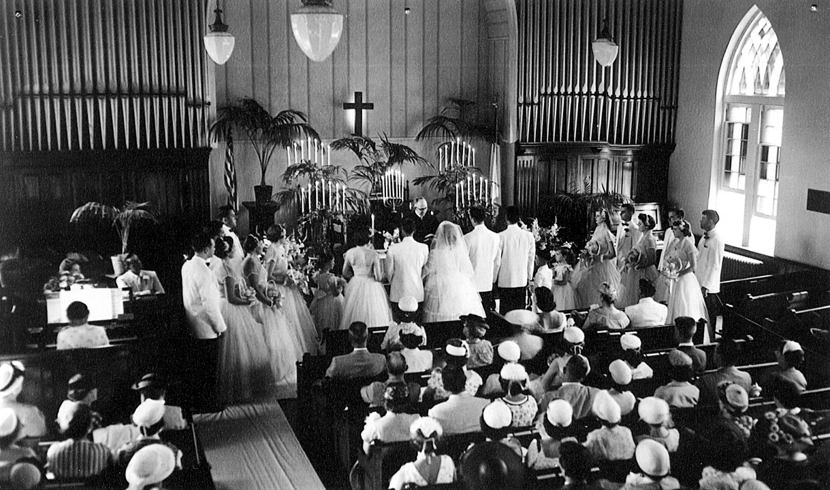
Typical Wedding Circa 1954 With Reverend Alfred R. Mays Presiding

Some of our early members lie in a cemetery started in back of the old church. These graves were interred between 1850 and 1870. Peter Cain who gave the land for Cain’s Chapel was among the last to be buried in our cemetery on June 23, 1872. Our cemetery was discontinued when the town’s Greenhill Cemetery was created. Over time the graves became lost and the scattered headstones were moved to a memorial area adjacent to our entrance.
The 1884 church stood for many years without any further changes until 1927 when needing more space, an addition was built onto the rear of the original building. This provided room for a new furnace room, a restroom, a kitchen, a church school office and a new pipe organ for the sanctuary. The cost of these additions was $13,000. During this time, Sunday School classes were held in the sanctuary and in the downstairs assembly rooms. In 1941, a new Sunday School was needed which led to another addition to the growing church under Rev. A. O. Lyons’s leadership. This provided an additional seven classrooms at a cost of $7,000. Within a short ten years, another Sunday School addition was built adding six more classrooms and another restroom for $12,000.00 under Rev. Percy D. White’s leadership.

Some of those deserving special recognition were George E. Phillips who donated considerable funds as well as large amounts of his time. He drew up the blueprints and specifications for the proposed 1884 building Another notable person was Phillip J. Affleck who served as Sunday School Superintendent from 1871 until his death in 1904. He was also very faithful throughout his stewardship bequeathing funds that provided for the future growth of our church. Another individual honorably mentioned is the Reverend Frank A. Strother who served long and faithfully by preaching at five other churches on his circuit while serving our congregation . A plaque honoring him is in the Stephens City Methodist Church stating that he helped to erect 40 churches while serving as a Circuit Rider. He died in 1925 and is buried in the Berryville Green Hill Cemetery, lot #95.
In 1939 the Methodist Episcopal Church South and the Methodist Episcopal Church North finally worked out their differences and voted in conference to unite the two churches to become The Methodist Church. It was during this reunification that our church renamed itself in honor of the Bishop William Wallace Duncan who presided over the Baltimore Methodist Conference South of which Berryville was a part of in 1894, 1900, 1901 and 1902. It was not until 1969 when further changes were adopted that further unification took place resulting in the United Methodist Church.
The late 1950’s and 1960’s saw a growing concern regarding the safety of the 1884 structure as it aged and planning was started for a new sanctuary. As the need for a larger property became obvious, in 1953 Dr. Carroll H. Iden donated the parking lot behind the old church as a memorial to the highly esteemed Mrs. Jane Iden, who served as Superintendent of the Children’s Division for many years. Meanwhile, during the early 1960’s, a new parsonage was required when Rev. Marvin Claude (Windy) Cook became our minister. ‘Windy,’ who was known for his lengthy conversations and sermons, and his family found the parsonage built in 1945 for $7,500 too small, Windy himself being over 6 feet tall. A new parsonage was built on Rosemont Circle for $65,000 and the old parsonage sold. In spite of the delay caused by the purchase of the parsonage, planning for the new church surged ahead. In 1967 the Wynkoop property next door to the church to the west was purchased for $16,000.
Using the grant by Phillip J. Affleck, phase one of the new church was built behind the 1884 church. The building committee, with Lawrence White Jr. leading, produced the following plans for phase one.
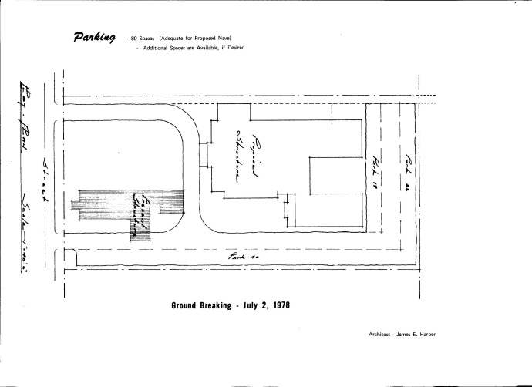
This depiction shows the original church on the left facing Main Street. Our new church is positioned behind it also facing the street. This shows the proposed position within our property limits at the time. The proposed interior layouts for the first phase of construction are shown below.

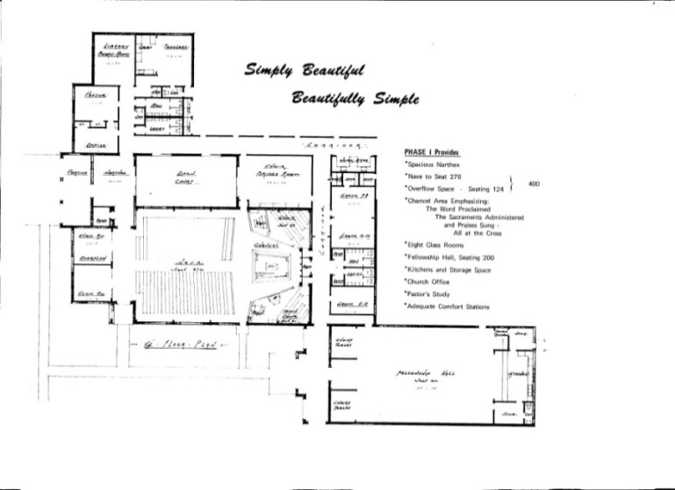

This represents the proposed interior referred to as phase one. It contains offices, 4 restrooms, library, toddlers room, 5 classrooms, choir room, 400-seat sanctuary, a large fellowship hall and a full kitchen.

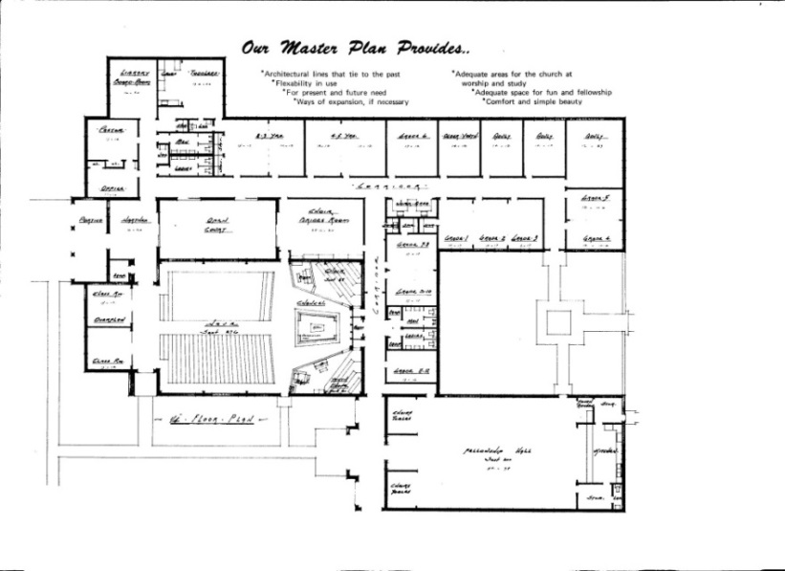

These plans known as phase two were to be added to phase one and built as funds became available. It enlarged our church to include the addition of 11 more classrooms. This closely represents what our church has become with some additional changes to accommodate our needs.

The phase one plans were built with Phase two to follow as soon as possible. The wisdom of the planning committee can only be admired when we consider how the physical layout of the building continues to serve the many new programs we’re currently offering those in our surrounding community some 36 years later. The 400-seat capacity sanctuary is also serving our congregational needs through all these many years. The fellowship hall has proven to be an asset to the entire community as it serves groups and agencies throughout the county.
The phase one construction was begun in July of 1978 by Ricketts Construction Company with a bid of $580,000. The cornerstone was laid May 20, 1979, with Dr. Lee B. Sheaffer, District Superintendent, as the speaker. The Rev. Marvin C. Cook, former pastor of Duncan Memorial led the service.

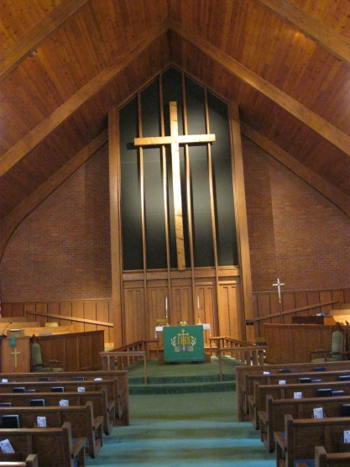
The cross mounted in the front of our current sanctuary was created from a large spruce tree that grew beside the old church. In 1979, as the phase one building was being planned and the area was being readied for construction, a large Spruce tree needed to be removed that stood on the west side of the church. (This tree can be seen standing beside the church in the previous picture of the old church.) Allen Cochran and Lawrence White Jr. hewed the timber from this tree to create the cross which adorns our current sanctuary. Several older members remember that after the cross was mounted in the new sanctuary, it cried as the sap dripped from it onto mats place below it to save the carpeting. It was recalled that the cross cried for over a year.
The Moller pipe organ that was moved to the new church was damaged when a leak developed in the roof in 1966. Extensive repairs requiring disassembly and reconditioning were performed during its repair. Over 94 donors are recorded as contributors to this major rebuild of the organ which is continuing to provide us with heavenly worship music to this day. As the new church became the worship center, many fixtures and furnishings were donated by the congregations members. These included contributions for pews, a processional cross, altar vases, the steeple, candelabras, a baptismal font and many other items too numerous to mention.

New stained glass windows were commissioned by donors to be installed in the sanctuary as follows:
Window 1: This window commemorates the Baptism of Jesus and our own baptism into the faith of our Lord and Savior; given to the Glory of God in memory of Powell Cobb Jr. by his wife, Nellie F. Cobb.
Window 2: “Do this in remembrance of me.” The Communion window is given in memory of Mr. and Mrs. Adolphus Feltner, the parents of Nellie F. Cobb.
Window 3: The Word to live by, a story of faith, the history of a nation’s search for the one true God. This window is given in memory of Mr. and Mrs. Henry McDonald and Emmett N. McDonald: the sister, brother-in-law and nephew of Nellie F. Cobb.
Window 4: A Prayer to the God of Israel and Christ sustains our faith and being. This window is given in memory of Mr. and Mrs. Rice Feltner and Marshall, the brother and sister-in-law and nephew of Nellie F. Cobb.
Window 5: The Service rendered in Christ’s name by feeding the hungry, caring for the sick, clothing the naked and visiting the prisoned, given by the Board of Trustees, Class of 1997, to the Glory of God for the service of past boards of trustees.
Window 6: The Law window given as a rule to govern the conduct of a nation and all individuals within and used by the superintendents of our church schools: to teach future generation of Christian leaders; given in thankfulness (INCOMPLETE)
Window 7: The Promised One was given by God to save His Creation from sin and destruction and to provide salvation for all of us. Given by Kenneth and Barbara Thomas to the Glory of God and in honor or their sons Andrew, Timothy and Nathan who were blessed by the nurturing of this church.
Window 8: Jesus said, “I am the Way, the Truth and the Light, anyone who comes to the Father comes by me.” This window is given by Alice and Herman Lloyd in memory of their parents Leonard J. and Alice Carper Langbein: John A. and Lula K. Bell Lloyd; and in honor of their children Karen, Betsy, John, and Laura.
Window 9: The Faithful of the early church gave others a shining example to follow. Identified by the symbol of the fish to protect themselves from prosecution, they anchored their faith in Christ. This window is given in thankfulness to God for John A. Brown by his wife Jean, his daughter Audrey Hudson, her husband Frances and his grandchildren Jean and John.
Window 10: The tenth window opens our lives to the Worship and praise of God and His greatness through music raised on high. This window is given in gratitude to God for the lives of Dudley Earl Brown and Rosa Costello Brown by their children Mr. and Mrs. Earl Brown Jr., and Mildred and Thomas Keating and all their grandchildren.

The stained glass windows in the two quiet rooms at the rear of the sanctuary were dedicated to St. Matthew and St. Mark in the left room and St. Luke and St. John on the right. The leftmost panel was donated by families and friends in memory of DMUMC Deceased Members. The right panel was donated by Grandparents Eugene V. White and Laura L. White in honor of Alexis M. and Kyle B. Hott. The left panel in the quiet room was donated in memory of Roy E. Potts Jr. by his wife, family and friends. The rightmost panel was donated in memory of Bernard J. Garrett by his family and friends. There is also a small stained glass octagonal window only visible from the outside of the church mounted in the peak of the wall above the windows of the quiet rooms. This was donated in memory of Melton R. Bean, Lottie F. Berkeley, Esta Brown, Charles R. Day, Maude Newton, Nellie C. Peffer, John Julias Pickeral, Dorothy Pickeral, Robert A. Unger Sr., Susan Ware and Beatrice L. White given by family and friends.

In 1979 the congregation moved into the new sanctuary. The removal of the 1884 building took place in 1980. The small wooden cross that was at the front of the old church now hangs in our church office. (this cross can be seen in the picture of the wedding.) Many artifacts were purchased by the membership while the old church was being dismantled, including pews and the stained glass windows. This area then became the new front vista of our current church.

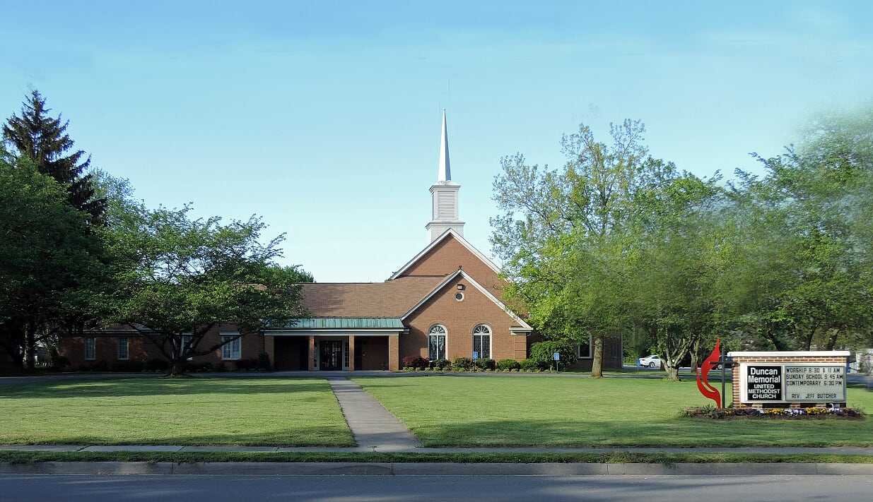

Phase two was initiated when Laura White, who chaired the phase two study group, was named Chairman of the Building Committee by the Special Charge Conference and was instructed to proceed with the plans as presented. Over the next 13 months beginning in July 1986, after many levels of approvals, on August 24, 1988, at a Special Charge Conference with District Superintendent, Thomas Coffman, presiding, the church accepted a bid of $543,118 for the Construction of phase two. H & W Construction of Winchester, Virginia, was selected as the project builder. The Chapel stained glass windows were created by the Shenandoah Studios of Stained Glass Inc. of Front Royal, Virginia.
Phase two proceeded rapidly in 1988 adding 15 more classrooms and the chapel to the existing phase one facility. With dividers in three of those rooms, this provided Sunday School space for grades 1 through 12, an older youth classroom, three adult classrooms, a choir room and a chapel. Laura also chaired the study committee that so thoughtfully designed the
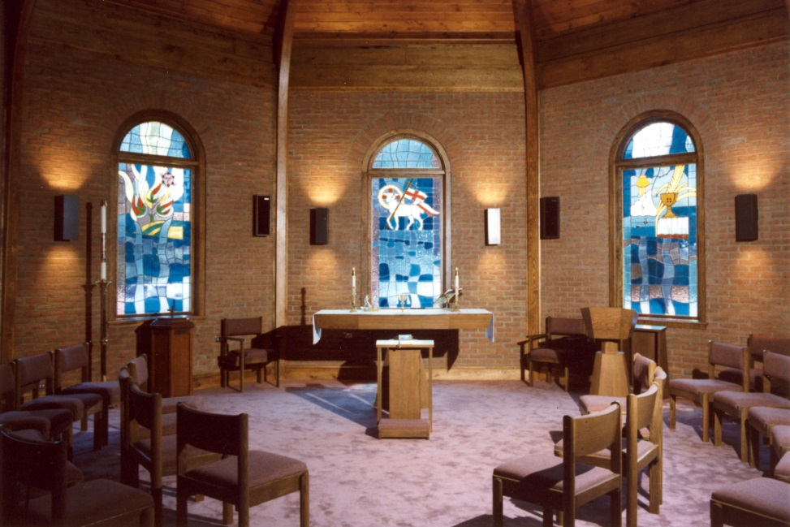
chapel. Along with the guidance of Rev. Dr. Daniel L. Garrett, the committee selected a theme of five acts relating the drama of the Bible. Five stained glass windows were created. The first facing east to the rising sun was ‘Creation.’ The second window reflects the ’Covenant’ made with his people. The third is ‘Christ’ representing the Lamb of God. The fourth window ‘Church’ represents the Church as the gathering place for Christians. Imbedded in this window are two stones the Rev. Dr. Garrett gathered during a trip to Israel. The lower stone is from the River Jordan where Jesus was baptized.. The upper stone is from the Sea of Galilee where Jesus called his first disciples. The fifth window is ‘Consummation.’ This last window reminds us of the promise and hope of a new heaven and a new earth. This completes the depiction of the Father, Son and Holy Spirit.

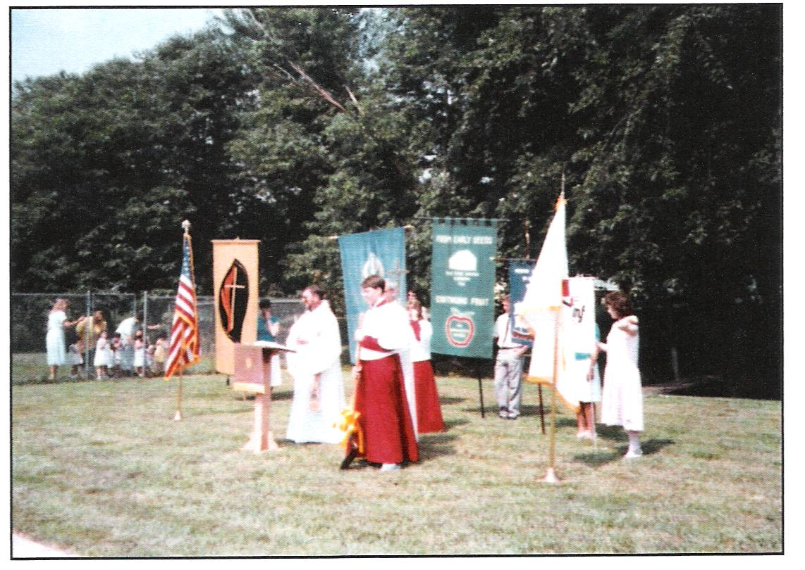
On Sunday, June 25, 1989, the new chapel and educational addition were dedicated in afternoon services. As part of the celebration of the chapel windows, five sermons were preached between September 3rd and October 1^{st,} 1989. On October 14, 1989, Bishop W. Kenneth Goodson and the Reverend Dr. Lee B. Sheaffer, District Superintendent, conducted Consecration services for our new Church. The Reverend James B. Goodwin was pastor of Duncan Memorial at the time and led the service.
With these new facilities, our church has continued to grow in service to the community. A large lot behind our church was willed to the church at the passing of sisters Anna (Wilt) Hawkins, Flossie (Wilt) Talley and Evelyn Wilt. A house that stood on the lot facing Liberty Street was deemed in poor repair and was removed.
In 2002 Molly Stickley, who owned properties at 205 and 207 Liberty Street passed and indicated in her will that the church should have first refusal on her lots. Our church purchased the properties in 2003 providing us all the lots behind our church all the way to Liberty Street assuring us of a future growth opportunity to expand in the future as God wills.
Our congregation’s service to our community has expanded in many ways over the past decades. When Rev. Harold E. Thornton was assigned to Duncan Memorial in 1996, his wife started a program called ‘Mothers Day Off’ which provided a babysitting service once a week for mothers. In 1998, the existing ‘Wee Angels Children’s Programs’ became fully licensed by the State of Virginia as a childcare and education provider. This grew into our current program the “Wee Angel EduCare Center” which is providing Day Care for 6 month to 1 year olds five days a week and a Pre-School for older children with both programs operating from 6:30 AM till 6:00 PM.
The community wide ice cream socials began in the early 1990’s. When Richard Byrnes’ family took over leadership of the program, production and popularity grew to producing 20 to 25 gallons to satisfy the demand. Most recently, 25 plus years later, the annual ice cream event has grown by popular request and is now producing over 60 gallons of up to a dozen flavors of ice cream which is made by Methodist Men volunteers under the direction of the Byrnes’. This has truly become a community event enjoyed by young and old alike.
Duncan Memorial has hosted many United Methodist events over the years due to our church being located centrally within our district and due to the size of our facilities. It’s a true testament to all those of faith that have preceded us in this congregation of Christians who have worshipped here at Duncan Memorial throughout these past 180 years. It fills one with awe and respect to think of all those who have struggled to continually improve the house of worship they served in over the years. From a small meeting house in 1838, to a larger one in 1871 to a ‘permanent’ building in 1884, constantly growing and never wavering as they built bigger and better facilities for the future in which to worship their God. Their foresight has provided us with a church enabling us to do His works within our community.
We can be very proud that God has worked His way through our predecessors in helping us help those in need around us as we provide for those less fortunate than we are. Our church has provided for those within our county and our community by providing food for needed nourishment for children identified through our local school system. In partnership with other churches within our county, we operate as one of three food collection sites. Volunteers assemble food packs on Tuesdays which are delivered to the designated schools on Thursdays. We supply 38 of the approximately 90 meal packages that are delivered weekly during the school year.
We also support other community groups like Relay For Life, Narcotics Anonymous, and support food for the needy around us by working with our local Social Services who use our facilities to effect the distribution in our county. A truck load of food arrives once a month at our Fellowship Hall where our sponsored Boy Scout Troop stages all the various food types on the tables for packing. Volunteers from the designated participating church on the following day load boxes with the many foods provided. The Social Services recipients then sign in and receive their allocated groceries. This distribution is made once a month..
We coordinate with other churches throughout our County to use our facilities to supply those in need with winter coats, we provide meeting space for Boy Scouts, Cub Scouts, Blankets From the Heart who knit blankets for newborns, United Methodist Women events in support of missions, United Methodist Men who sponsor or support events such as the Homemade Ice Cream event or their annual Oyster sale at Christmas. We also run a Rummage sale out of our Fellowship Hall in April and September and a Bazaar in early November as UMW fund raisers to support missions.
Church programs include Wee Angels Pre-School, Vacation Bible School each summer, Sports Week which is a community wide children’s program for Kindergarten through 5th Grade children, Trunk or Treat Halloween event at the church for safe trick or treat time for small children. A new program called ‘Rise’ for teenagers is gaining success in that age group. For the older folks among us along with the Sunday School classes, we have the Roaring 60’s Fellowship Group. They will meet at a home or a local restaurant for fellowship.
Duncan Memorial’s long heritage of leading worship in our community is one of growing our faith for the future. Many unnamed Saints throughout our past and present have provided our church with the means for growth of our Christian beliefs into the future by providing a better place to worship and space to expand. They brought us from their humble small building on a half-acre lot on East Main Street to a church that is providing outreach and service to not only our village of Berryville but to our entire county of Clarke. Our future has never looked brighter in our mission to serve those around us. We owe our thanks to those on whose shoulders we stand in our Christian commitments.

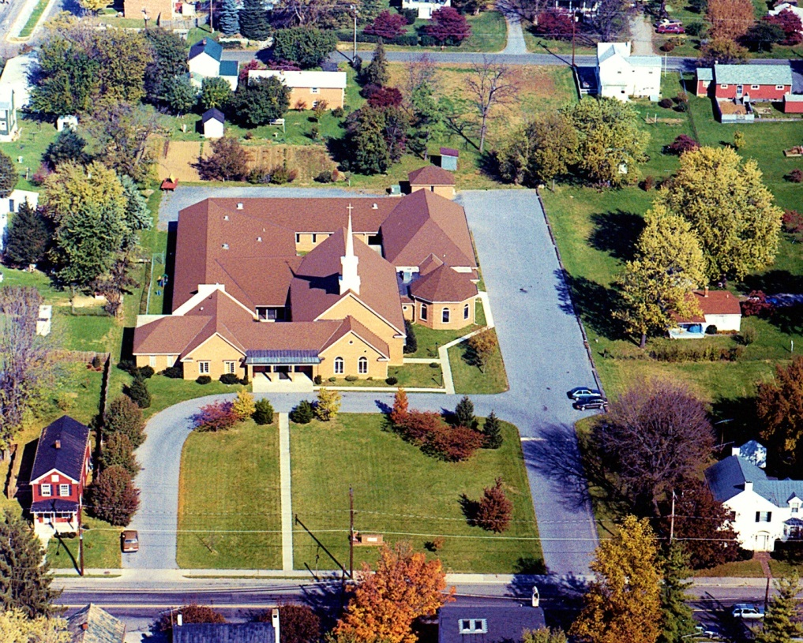

To our future in Christ.

